Architectural Components - State

📝Definition
# Source: AI Source: Provided by: [Data Path: Persons Table -> ID Column: 1, Name_En Column: Motasem Essam] -> From: [ChatGPT] on [1/23/2026]
In software design, state refers to the current condition or stored data of an object, component, or system at a specific point in time.
👉 Think of it as “what the system knows right now”.

🔑 Key Points About State
# Source: AI Source: Provided by: [Data Path: Persons Table -> ID Column: 1, Name_En Column: Motasem Essam] -> From: [ChatGPT] on [1/23/2026]
- Represents Data: Any data that describes the current situation.
- Changes Over Time: State can be updated by user actions, events, or business logic.
- Determines Behavior: The system often behaves differently depending on its current state.

🧩 Examples

1️⃣ Shopping Cart (Model State)
# Source: AI Source: Provided by: [Data Path: Persons Table -> ID Column: 1, Name_En Column: Motasem Essam] -> From: [ChatGPT] on [1/23/2026]
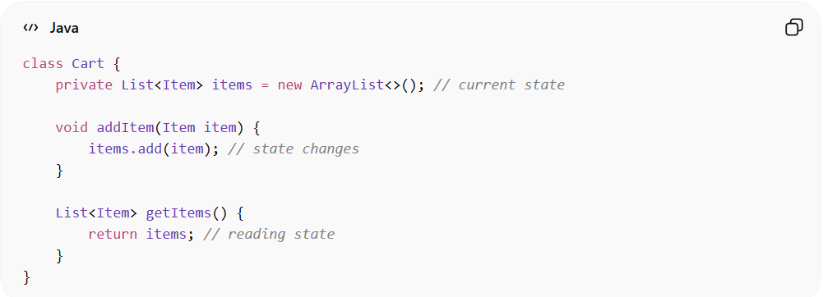
class Cart {
private List<Item> items = new ArrayList<>(); // current state

void addItem(Item item) {
items.add(item); // state changes
}

List<Item> getItems() {
return items; // reading state
}
}
- State: items in the cart
- Behavior depends on state: Cannot checkout if items is empty

2️⃣ User Session (State in Web App)
# Source: AI Source: Provided by: [Data Path: Persons Table -> ID Column: 1, Name_En Column: Motasem Essam] -> From: [ChatGPT] on [1/23/2026]
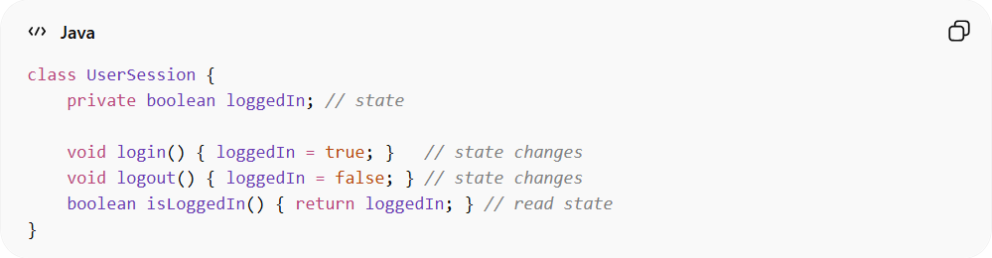
class UserSession {
private boolean loggedIn; // state

void login() { loggedIn = true; } // state changes
void logout() { loggedIn = false; } // state changes
boolean isLoggedIn() { return loggedIn; } // read state
}
- State: loggedIn
- Behavior depends on state: Only logged-in users can access certain pages

3️⃣ UI Component (State in Frontend)
# Source: AI Source: Provided by: [Data Path: Persons Table -> ID Column: 1, Name_En Column: Motasem Essam] -> From: [ChatGPT] on [1/23/2026]
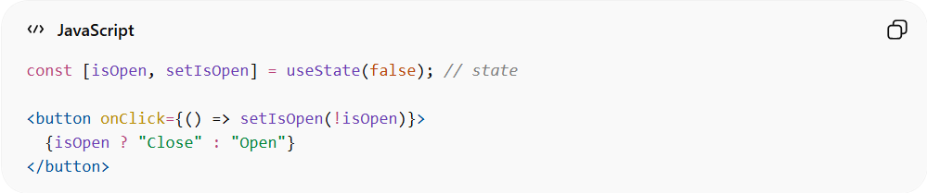
const [isOpen, setIsOpen] = useState(false); // state

<button onClick={() => setIsOpen(!isOpen)}>
{isOpen ? "Close" : "Open"}
</button>
- State: isOpen
- Behavior depends on state: Button text and panel visibility change

⚡ Key Idea
# Source: AI Source: Provided by: [Data Path: Persons Table -> ID Column: 1, Name_En Column: Motasem Essam] -> From: [ChatGPT] on [1/23/2026]
State = the “current snapshot” of data or conditions that defines how an object or system behaves at a given moment.

In short:
# Source: AI Source: Provided by: [Data Path: Persons Table -> ID Column: 1, Name_En Column: Motasem Essam] -> From: [ChatGPT] on [1/23/2026]
- Model manages state → stores the data
- View reacts to state → displays current data
- Controller/ViewModel modifies state → updates data

